Task 2: Automate PNG Transfer Between S3 Buckets Using AWS Lambda

# 🎯 Objective

Create a serverless automation using AWS Lambda that triggers on file upload to 'bucket1', filters for '.png' files, and copies them to a designated folder in 'bucket2'. This should include error handling.

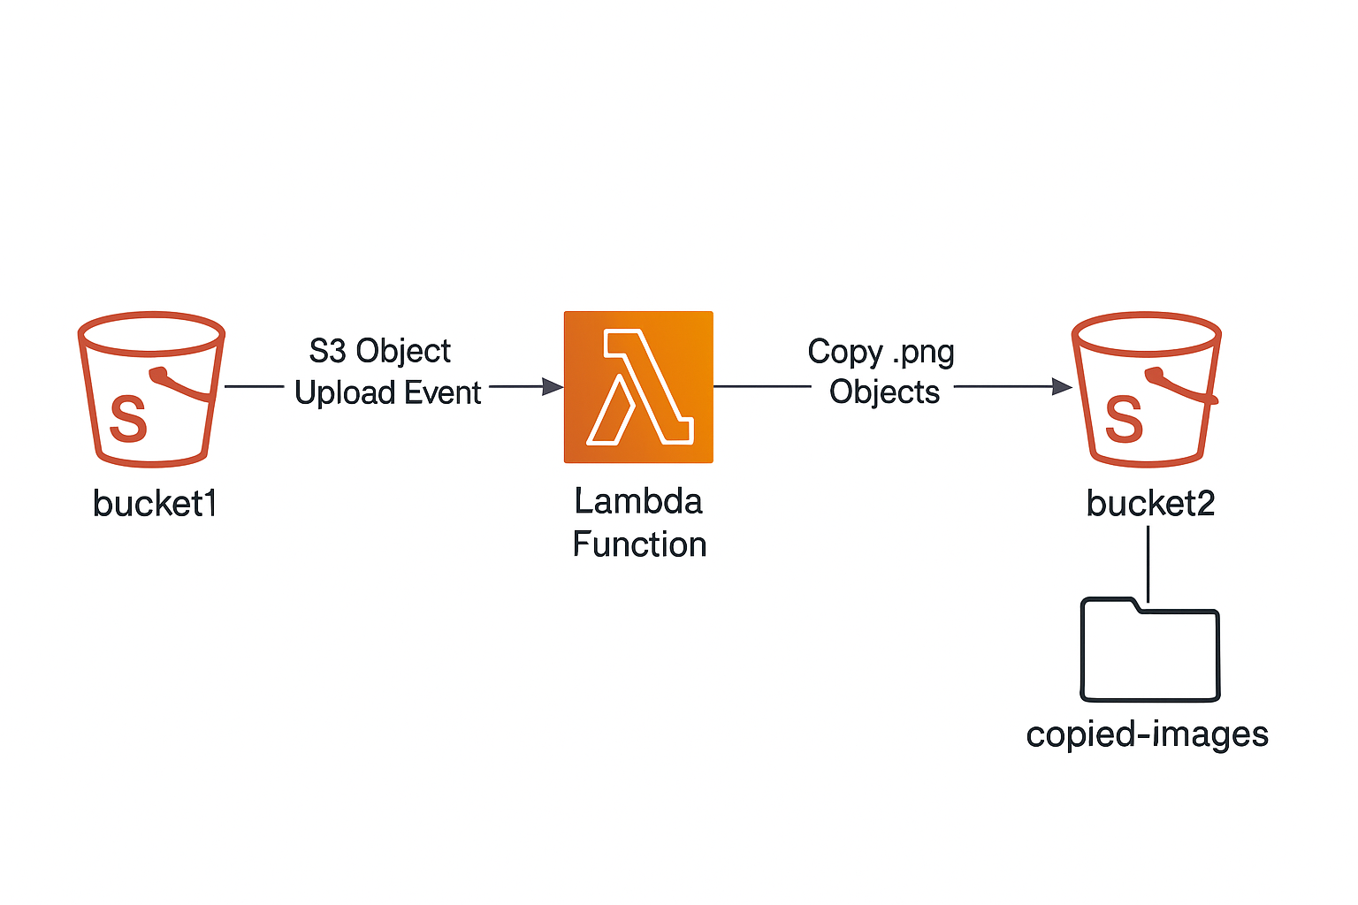

# ✅ Step-by-Step Instructions

## Step 1: Create Two S3 Buckets

* Go to the AWS S3 console.
* Create two buckets:
* - bucket1 – source bucket
* - bucket2 – destination bucket
* Keep them in the same region to avoid cross-region costs or permissions complexity.
* Buckets:
* Bd1-1(dest)
* Bs1-1(src)
* 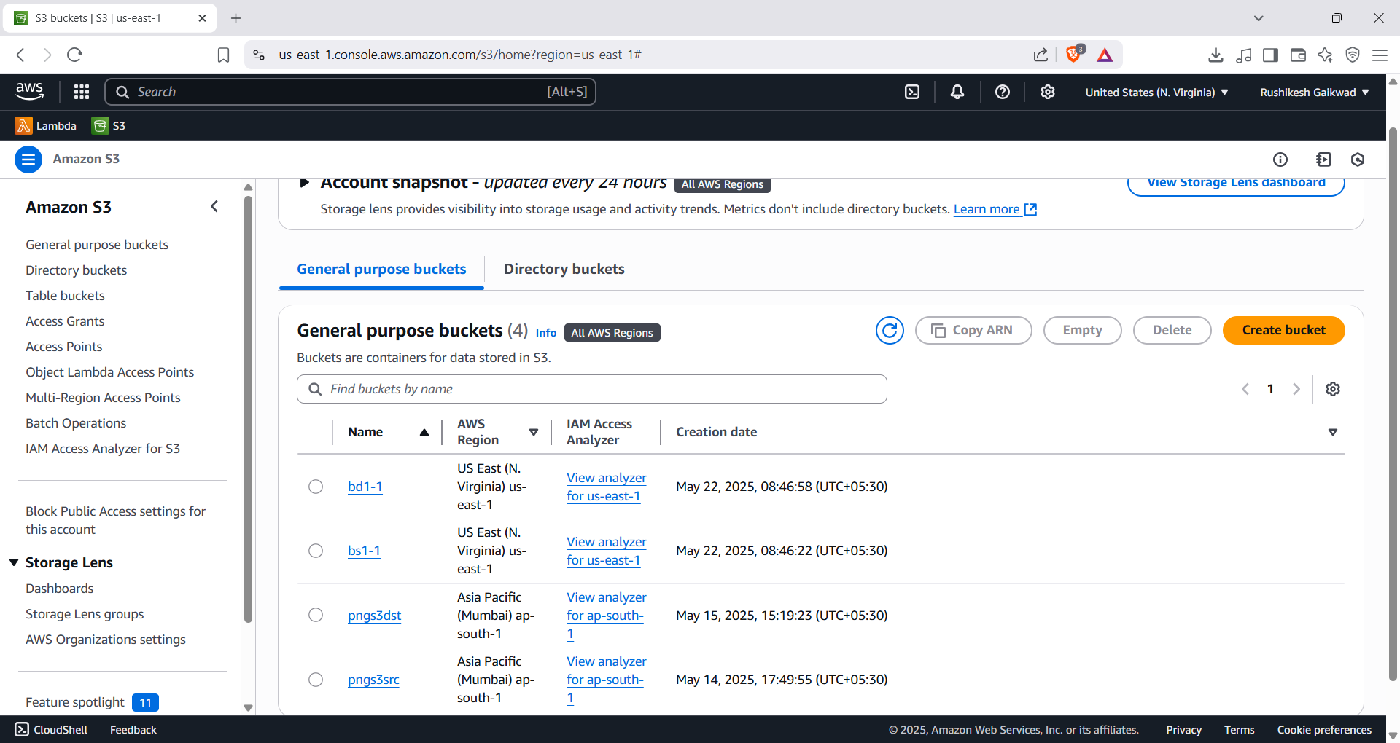

## Step 2: Create the Lambda Function

* Go to the AWS Lambda console.
* Click “Create function”.
* Choose 'Author from scratch', give a name (e.g., CopyPNGtoBucket2), choose Python 3.12
* Create a new role with basic Lambda permissions.
* Click 'Create Function'.

Function name is : copypng

* 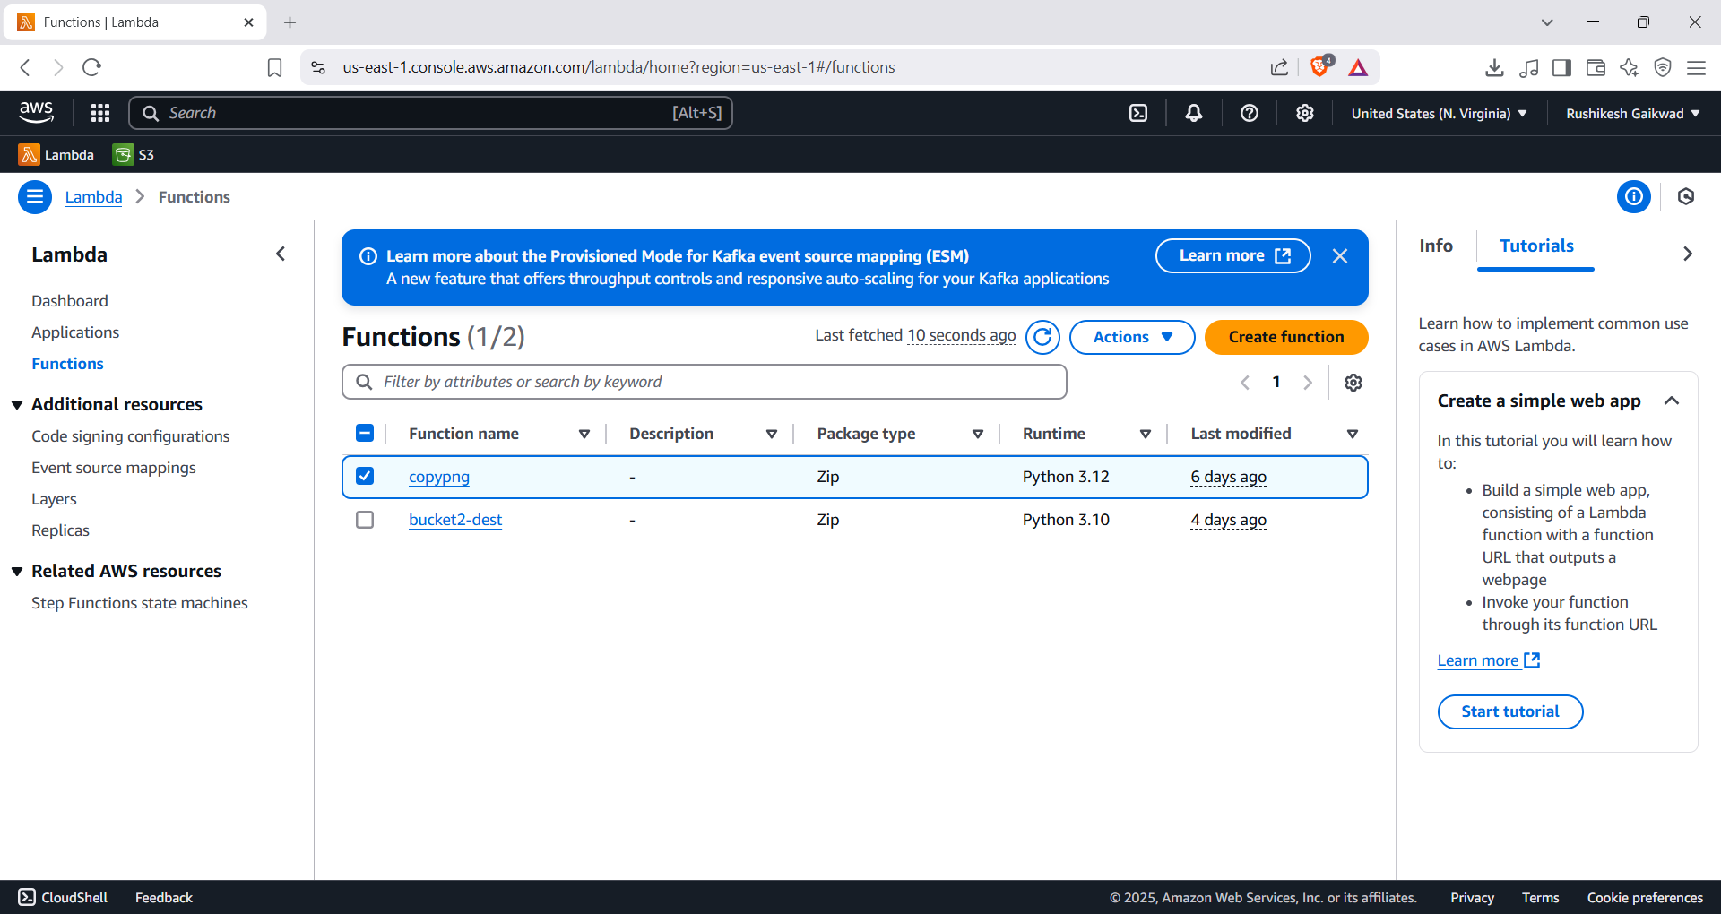

## Step 3: Add S3 Trigger to Lambda

* In Lambda's 'Designer' section, click '+ Add trigger'.
* Select S3, choose 'bucket1', set event type to 'PUT'.
* Enable the trigger.
* 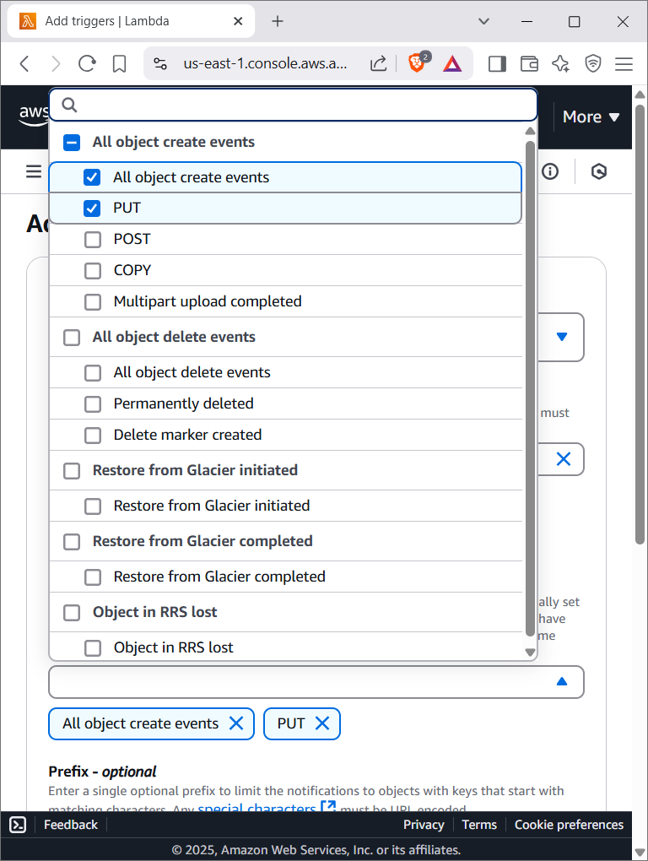
* You should choose only put here

## Step 4: Update IAM Role Permissions

* Go to IAM → Roles → [Your Lambda Role] → Add permissions.
* Attach the following inline policy:
* {  
   "Version": "2012-10-17",  
   "Statement": [  
   {  
   "Effect": "Allow",  
   "Action": ["s3:GetObject"],  
   "Resource": "arn:aws:s3:::bucket1/*"  
   },  
   {  
   "Effect": "Allow",  
   "Action": ["s3:PutObject"],  
   "Resource": "arn:aws:s3:::bucket2/*"  
   }  
   ]  
  }

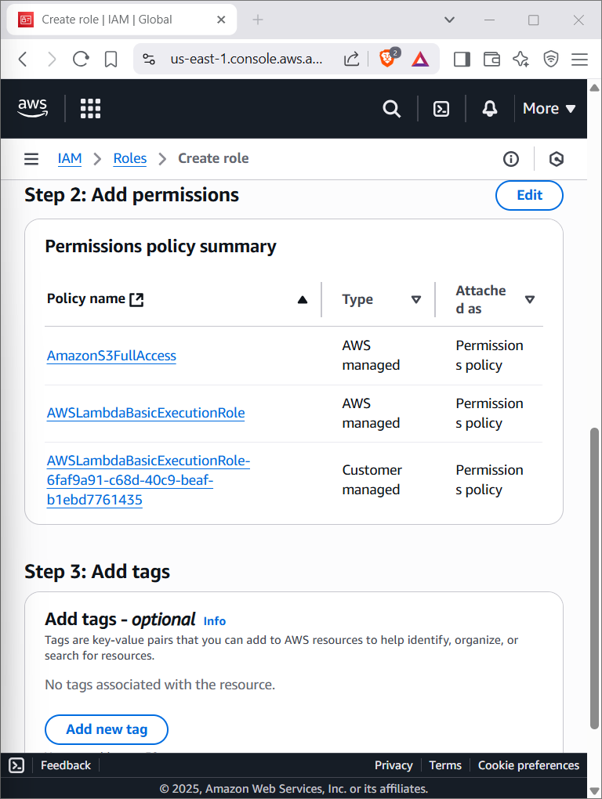

## Step 5: Lambda Function Code

* Paste this code in the Lambda editor:

import boto3

import urllib.parse

s3 = boto3.client('s3')

def lambda_handler(event, context):

try:

source_bucket = event['Records'][0]['s3']['bucket']['name']

key = urllib.parse.unquote_plus(event['Records'][0]['s3']['object']['key'])

if not key.lower().endswith('.png'):

print(f"Not a PNG file: {key}")

return

destination_bucket = 'bucket2-yourname'

destination_key = f"copied-images/{key.split('/')[-1]}"

s3.copy_object(

CopySource={'Bucket': source_bucket, 'Key': key},

Bucket=destination_bucket,

Key=destination_key

)

print(f"Copied {key} to {destination_bucket}/{destination_key}")

except Exception as e:

print(f"Error copying {key}: {e}")

raise e

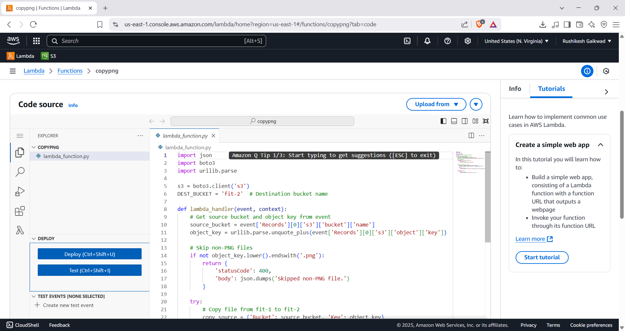

## Step 6: Test the Setup

* Upload a '.png' file to 'bucket1'.
* Check 'bucket2/copied-images/' for the file.
* Verify non-PNG files are ignored.

Successfully image is getcopied in bd1-1

